**JAVA SCRIPT PART 9**

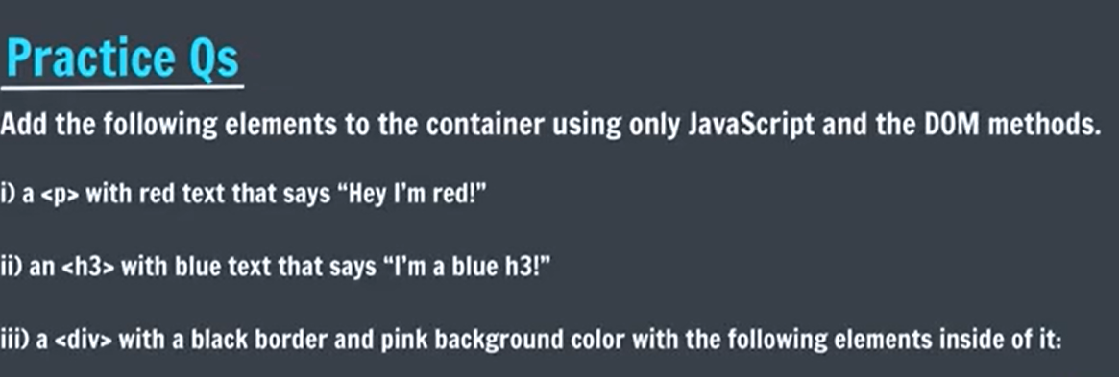

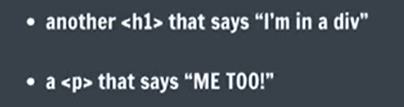

**ANS1:**

**In Js file:**

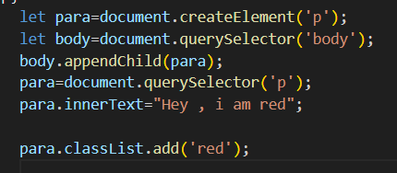

**In css file:**

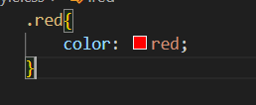

**Output:**



**Ans2:**

**In js file:**

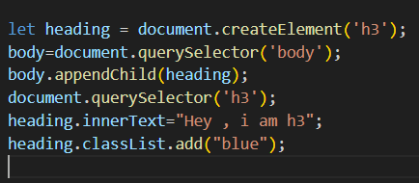

**In css file:**

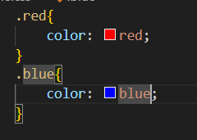

**Output:**



**Ans 3:**

**In js file:**

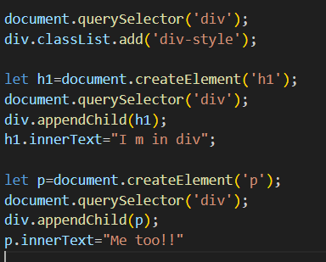

**In css file:**

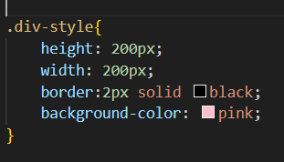

**Output:**

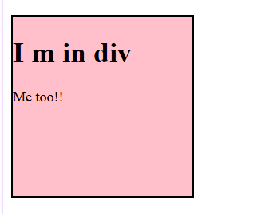

**Practice set 2**

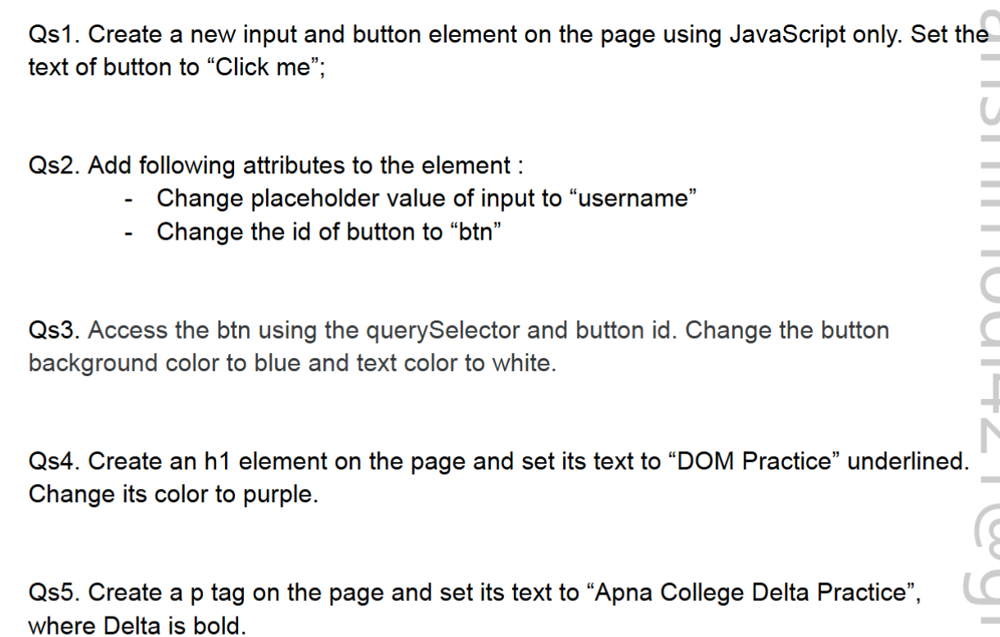

Ans 1:

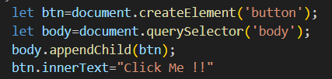

Ans 2:

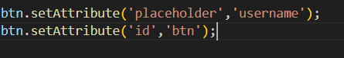

Ans 3:

IN JS FILE:

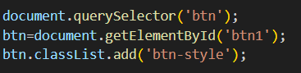

IN CSS FILE:

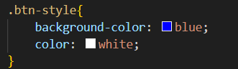

Ans 4:

IN JS FILE:

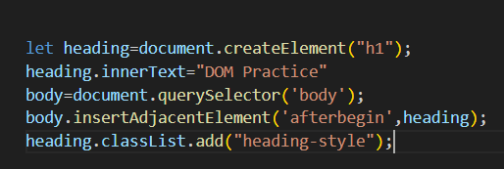

IN CSS FILE:

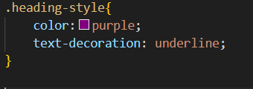

Ans 5:

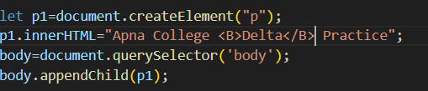

OUTPUT:

